Python Program to Exchange the Values of Two Numbers using ^ (exclusive or operator)

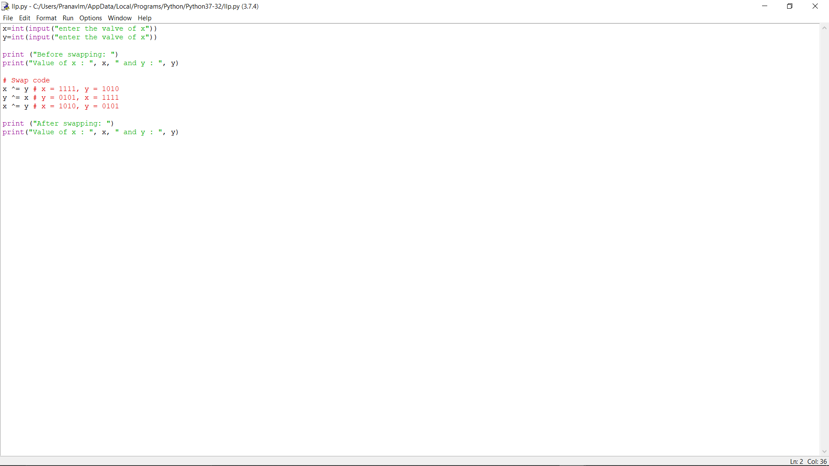

OUTPUT

